LARAVEL PROJECT CATALOQUE

I have worked on several projects. This are some of the modules that I have incorporated in various projects.

1. AUTHENTICATION.

I have integrated several authentication packages such as Laravel breeze and Jetstream . Below are a few screenshots of this.

Laravel Breeze

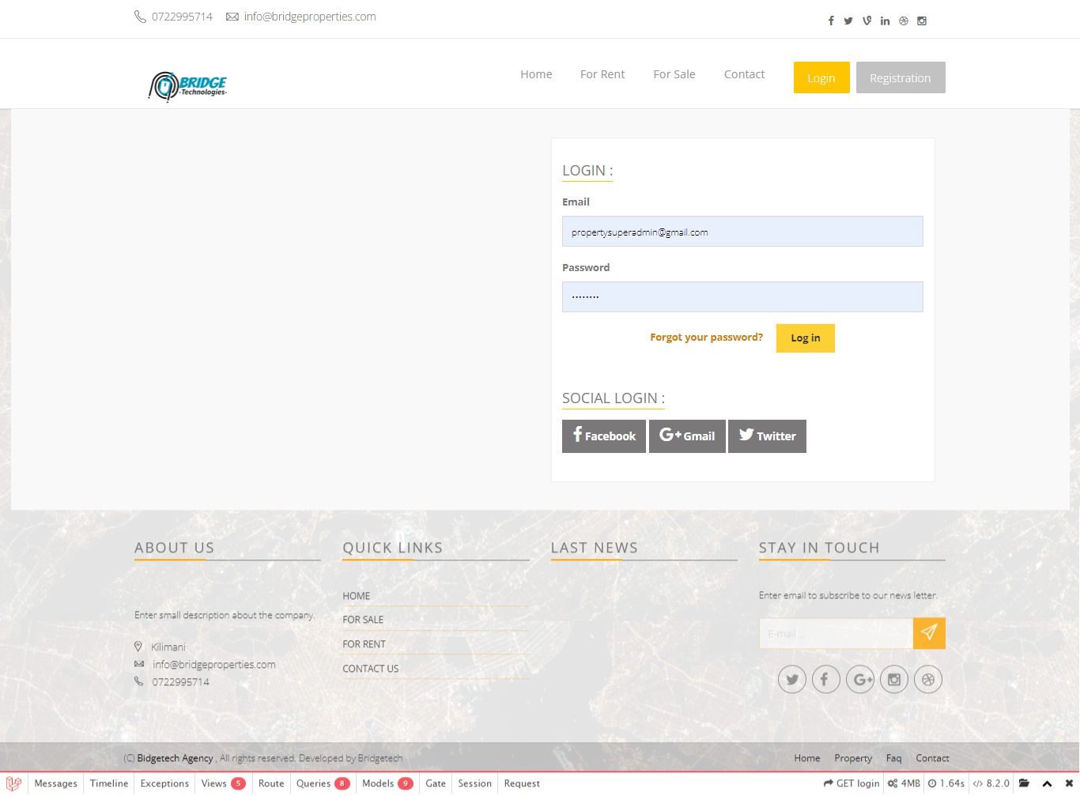

Using Laravel Jetstream.

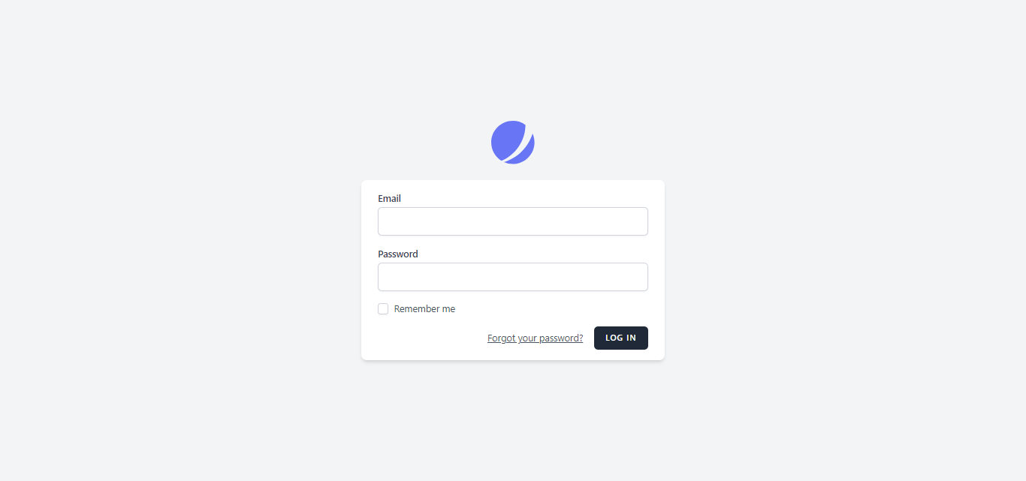

1. AUTHORIZATION

I have also developed several user management modules.